## 1. RPA Use Case – Network Alarm Monitoring and Resolution Process Workflow:

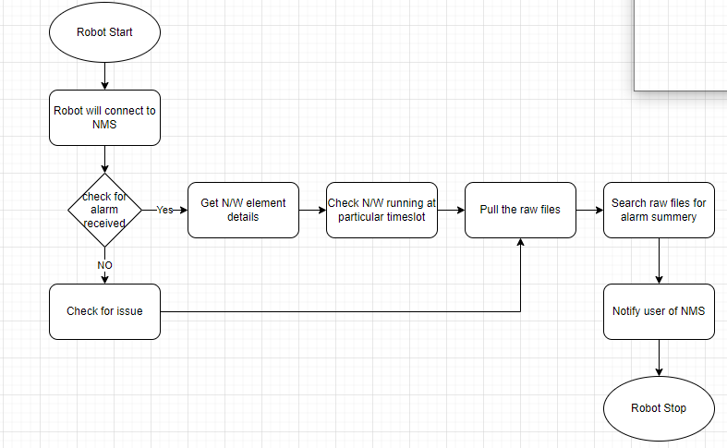

## 2. RPA Use Case – Alarm received but not processed on NMS Process Workflow:

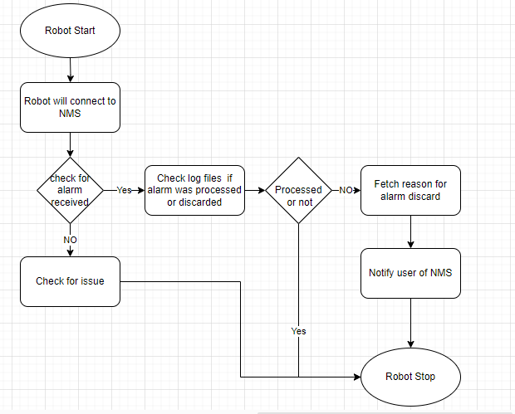

## 3. RPA Use Case– Alarm received on Network Management System Process Workflow:

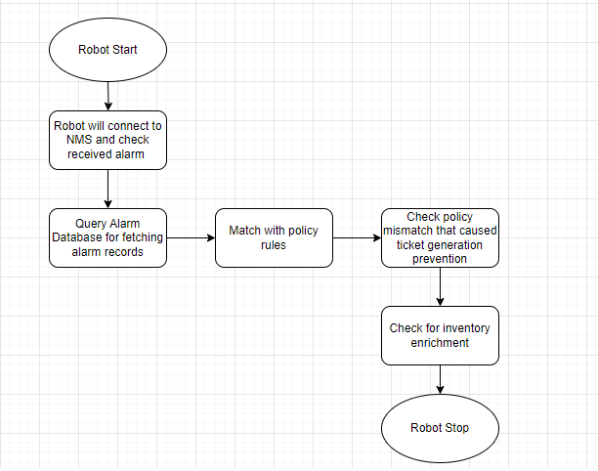

## 4. RPA Use Case – Ticket Investigation and Resolution Process Workflow:

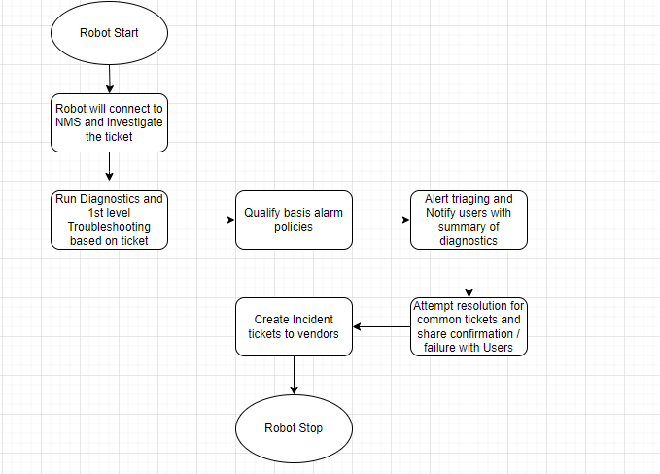

## 5. RPA Use Case – Monitoring and Highlighting Exceptions Process Workflow:

## 